DETAIL - LEVEL DESIGN DOCUMENT

Telangana State Domestic Power Consumption Data

Azure Cloud SQL Server

**Version: 1.0**

**Created Date: 17/03/2023.**

Revision History

|  |  |  |  |
| --- | --- | --- | --- |
| Version | Date | Created By | Reviewed By |
| 1.0 | 17-03-2023 | Jayachandra babu |  |
|  |  |  |  |
|  |  |  |  |
|  |  |  |  |
|  |  |  |  |

TABLE OF CONTENTS

Contents

1. Steps to be followed to load data to Azure Blob Storage**……………………………………………......**4

2. Steps to be followed to create view for BI report 6

3. Steps to be followed to create BI Reports 6

**1**. Steps to be followed to load data to Azure Blob Storage

## 1.1 Created Storage Account and Uploaded Raw Data

Import the Raw Data into Source using Mapping Data Flow

Created Backup Folder

Created Azure SQL Database

Transforms the Data to Sink using Mapping Data Flow

Successfully Debug the Pipeline

# Steps to be followed to create view for BI report.

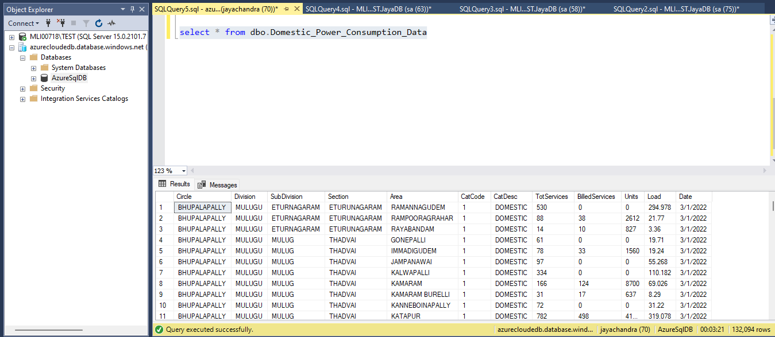

# 3. Steps to be followed to create BI Reports

**Step 3.1:** We have built this report using desktop Power BI tool and Published to the web:

* **Overall Statistics of Domestic Power Consumption Data** which has below visuals:
  + Slicer for date, division, subdivision, and area
  + Data-cards for Total Services and max load
  + clustered column charts for subdivision wise circle by units.
  + Line and clustered column charts for billed services wise units by circle.
  + Stacked bar chart for load by area.
  + Waterfall chart for division wise area, catdecs and load.
  + Donut chart for Year wise units
  + Gauge chart for total services by load.
  + Matrix for circle wise details.

Azure SQL Database Connection to Power BI Desktop

Imported Data into Power BI Desktop

Power BI Data View

Power BI Data Modelling

Build the Data Visualization

Publish The Report

Successfully publish the report into Workspace

3.2 Installing Gateway and adding Data Sources

Adding the Gateway to the Dataset

Connected to Data Source

Adding the Schedule Refresh Daily and Weekly

Report Schedule Refresh Successful

Published Power BI report can be found here:

[Domestic Power Consumption Report - Power BI](https://app.powerbi.com/groups/334273fc-9456-48a5-be5d-a0d4ae3487b1/reports/a3616362-ec12-4de2-8ef4-13bd839f9e04/ReportSection)

[Domestic Power Consumption Report.pbix](https://corpusmobilelabs-my.sharepoint.com/:u:/g/personal/jayachandra_katta_motivitylabs_com/EYULKMnXajlBp_ZQA0tjiqcBSMygojrwnc7sttHSPjhmew?e=WNzcza)